- List 3 real-world devices in your home or college that use SMPS (Switched Mode Power Supply) and 2 devices that use UPS (Uninterruptible Power Supply), explaining in one line why each device needs that type of power supply.

SMPS (Switched Mode Power Supply)
Computer/PC: Uses SMPS to convert AC power into the different DC voltages required by computer components.
LED TV/Monitor: Uses SMPS because it provides efficient and stable power while keeping the device compact.
Laptop Charger: Uses SMPS to efficiently convert household AC electricity into the lower DC voltage needed to charge and run the laptop.
UPS (Uninterruptible Power Supply)
Desktop Computer: Uses a UPS to provide temporary backup power during a power cut and prevent sudden shutdowns.
Wi-Fi Router: Uses a UPS to keep the internet connection running during short power interruptions.

2. Draw and label a diagram showing the main internal components of a typical SMPS unit found in a desktop PC, including AC input, rectifier, transformer, and DC output sections.You can hand-draw and upload a photo, or use any free diagram tool like draw.io.

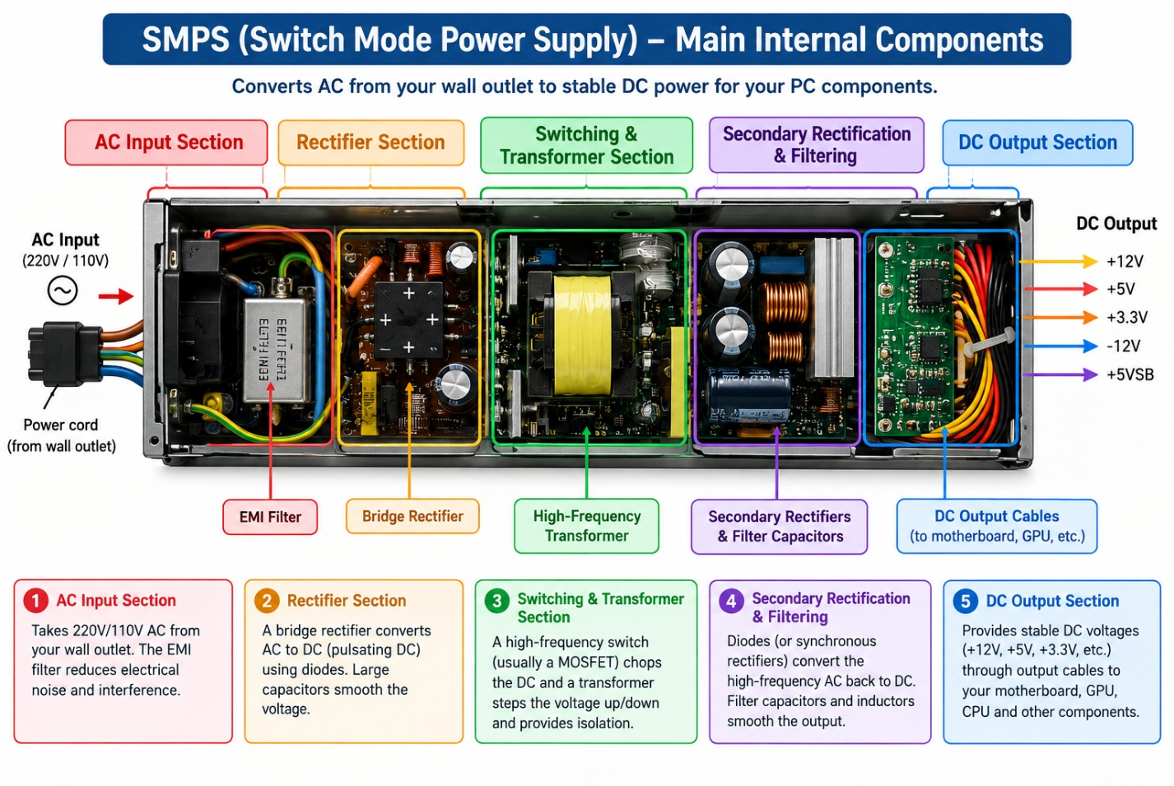

- Take photos or find clear images online of the following power connectors: ATX 24-pin motherboard connector, SATA power connector, Molex connector, and PCIe 6/8-pin connector. For each, write its name, the devices it powers, and one safety tip for connecting/disconnecting it
- ATX 24-pin
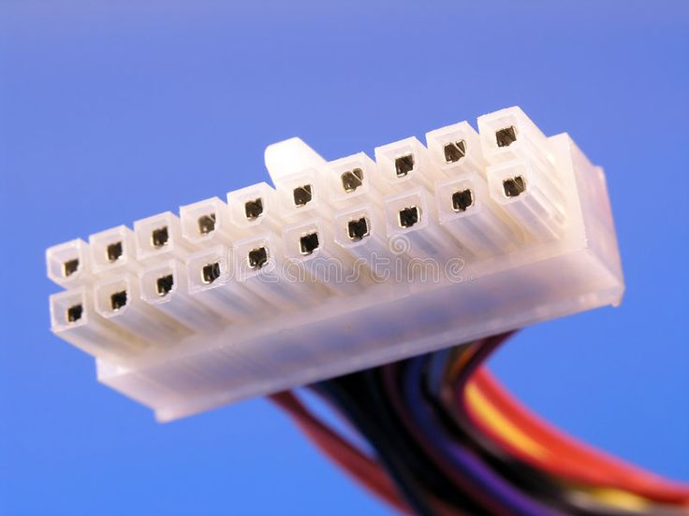
The ATX 24-pin connector is the main power connector from the SMPS/PSU to the motherboard. It supplies the required power to the motherboard and its components. The connector has 24 pins arranged in two rows of 12.

2. SATA power connector

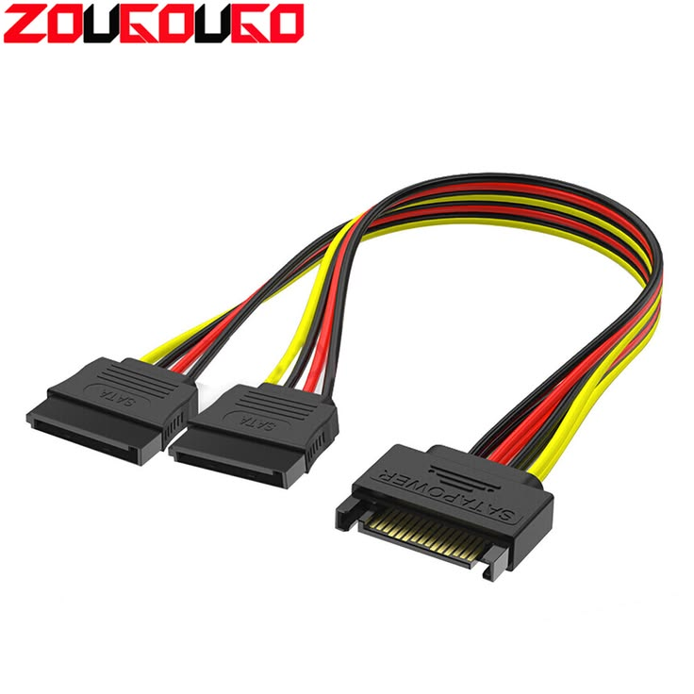
The SATA power connector is used to supply power to SATA HDDs, SSDs, and optical drives. It is a wide, thin connector with a keyed shape so it fits in the correct direction.
Safety tip: Turn off and unplug the PC before connecting or disconnecting it, and do not force the connector because SATA connectors can be fragile.
3 - PCIe 6/8-pin connector

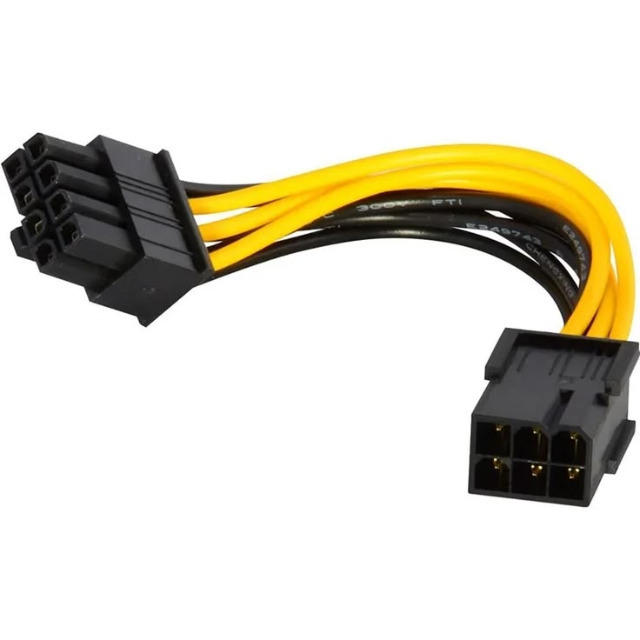

The PCIe 6/8-pin connector supplies extra power from the PSU to a dedicated graphics card (GPU). A 6+2-pin connector can be used as either a 6-pin or 8-pin connection. 
Safety tip: Turn off and unplug the PC before connecting or disconnecting it, and use the correct PCIe cable—not the CPU/EPS cable.

- Imagine you are setting up a new gaming PC. List the steps you would follow to connect the SMPS to the motherboard, graphics card, and storage devices, mentioning which specific cables and connectors are used for each.

Step 1: Turn off the PC, unplug the SMPS, and make sure all components are properly installed.
Step 2: Connect the 24-pin ATX power connector from the SMPS to the motherboard’s main power socket.
Step 3: Connect the 4/8-pin CPU/EPS power connector from the SMPS to the motherboard near the CPU socket.
Step 4: Connect the PCIe 6/8-pin power cable from the SMPS to the graphics card if the GPU requires additional power.
Step 5: Connect the SATA power cable from the SMPS to SATA HDDs, SATA SSDs, or optical drives.
Step 6: Check that every connector is fully inserted and locked, then connect the SMPS to the wall power and switch on the PC.
Step 7: Start the gaming PC and check that the motherboard, GPU, and storage devices receive power and work correctly.

